PERKINS V

CLNA WORKSHEET PACKET
San Diego Community College District
2023-24
For the 2024-25 and 2025-26 CLNA – due Spring 2024

Following the SDCCD CLNA Reporting Guide
This worksheet packet is tied to the Districtwide CLNA Reporting Guide. The Districtwide Guide includes:
- Districtwide agreements on consistent practices and responsibilities
- Recommended Materials and/or Data to Compile for Review
- Recommended Questions to Ask
- Recommended Data Review Questions to Inform Planning

This worksheet packet provides space for the documentation of each institution’s local CLNA processes and outcomes.

Submitting Your CLNA
San Diego City College, Mesa College, Miramar College, and the College of Continuing Education will utilize this to submit the required CLNA components to the District Office. These materials will be compiled into one districtwide CLNA and uploaded to NOVA.
- See most recent past Districtwide CLNA here.

Documentation – Being Audit Ready

Institutions will hold the following on file:
- Process documentation for local needs assessment
- Documentation of data collected and reports reviewed for required CLNA elements 1-6
- Documentation of stakeholder feedback
- Meeting agendas and minutes from CLNA (stakeholder engagement meetings, data review discussions, planning team meetings, etc.)
- Career education program advisory committee meeting minutes
- Career education program advisory committee membership lists
- Data reviewed regarding program size, scope and quality for all Perkins funded programs
- Districtwide Consultation Plan
- Regional Consultation Reports

Institutions will submit the following to the District:
- Completed districtwide reporting worksheet packet
Worksheet Components
Executive Response Summary Narrative 4
Narrative on Local Planning Team Process 5
Narrative on Stakeholder Engagement and Feedback 6
Membership Stakeholder List 7
CLNA ELEMENT #1 - Student Performance 8
2020 CLNA priority strategies 8
Will your institution be continuing or revising these priorities? 8
Data Reviewed 8
Observations made from data review(s) and constituent engagement activities 8
Priorities & Strategies 8
Action Plan (s) 9
CLNA ELEMENT #2 - Program Size, Scope, and Quality to meet the needs of all Students 10
2020 CLNA priority strategies 10
Will your institution be continuing or revising these priorities? 10
Data Reviewed 10
Observations made from data review(s) and constituent engagement activities 10
Priorities & Strategies 10
Action Plan (s) 11
CLNA ELEMENT #3 - Progress towards Implementation of CTE Programs of Study/Career Pathways 12
2020 CLNA priority strategies 12
Will your institution be continuing or revising these priorities? 12
Data Reviewed 12
Observations made from data review(s) and constituent engagement activities 12
Priorities & Strategies 12
Action Plan (s) 13
CLNA ELEMENT #4 - Improving recruitment, retention, and training of CTE professionals, including underrepresented groups 14
2020 CLNA priority strategies 14
Will your institution be continuing or revising these priorities? 14
Data Reviewed 14
Observations made from data review(s) and constituent engagement activities 14
Priorities & Strategies 14
Action Plan (s) 15
CLNA ELEMENT #5 - Progress towards equal access to CTE programs for all students 16
2020 CLNA priority strategies 16
Will your institution be continuing or revising these priorities? 16
Data Reviewed 16
Observations made from data review(s) and constituent engagement activities 16
Priorities & Strategies 16
Action Plan (s) 17
CLNA ELEMENT #6 - Alignment to Labor Market Information (LMI) 18
2020 CLNA priority strategies 18
Will your institution be continuing or revising these priorities? 18
Data Reviewed 18
Observations made from data review(s) and constituent engagement activities 18
Priorities & Strategies 18
Action Plan (s) 19
Coordination Strategy 20

Executive Response Summary Narrative
Required Narrative

Each Institution will submit responses to the below questions as a summary of their CLNA along with their local application. Answers will be compiled and submitted to the State via the NOVA online application within the “Local Needs Assessment” section.

Summarize the specific insight gained in the needs assessment related to each required element. Questions provided by the State as listed within the 2020 NOVA application.

- CLNA Element #1: Provide a summary of Student Performance on Required Performance Indicators (Disaggregated)
Max Characters: 625 characters per institution response

- CLNA Element #2: Provide a summary of Program Size, Scope, and Quality to meet the needs of all Students
Max Characters: 625 characters per institution response

- CLNA Element #3: Provide a summary of Progress Towards Implementation of CTE Programs of Study
Max Characters: 625 characters per institution response

- CLNA Element #4: Provide a summary of Improving recruitment, retention, and training of CTE professionals, including underrepresented groups
Max Characters: 625 characters per institution response

- CLNA Element #5: Provide a summary of Progress towards equal access to CTE programs for all students
Max Characters: 625 characters per institution response

- CLNA Element #6: Provide a summary of Alignment of programs to Labor Market Information (LMI)
Max Characters: 625 characters per institution response

Narrative on Local Planning Team Process
Required narrative

Each institution will provide a statement on how their local planning team / engagement with stakeholders is managed, convened, frequency, etc.
5,000 character limit

Narrative on Stakeholder Engagement and Feedback
Required narrative
Each institution will provide a statement on how local stakeholders were engaged during the needs assessment and summarize key stakeholder feedback. Complete stakeholder feedback will be recorded and held on file within the institution.
5,000 character limit.

Membership Stakeholder List
Required element

Provide List of Stakeholders
This list may be provided as a separate document and/or inserted within or at the end of this worksheet packet.
- Each institution may utilize the State’s 2020 template for listing stakeholders (see appendix A within State Resources).
- Each institution is committed to the regional expanded consultation Model:
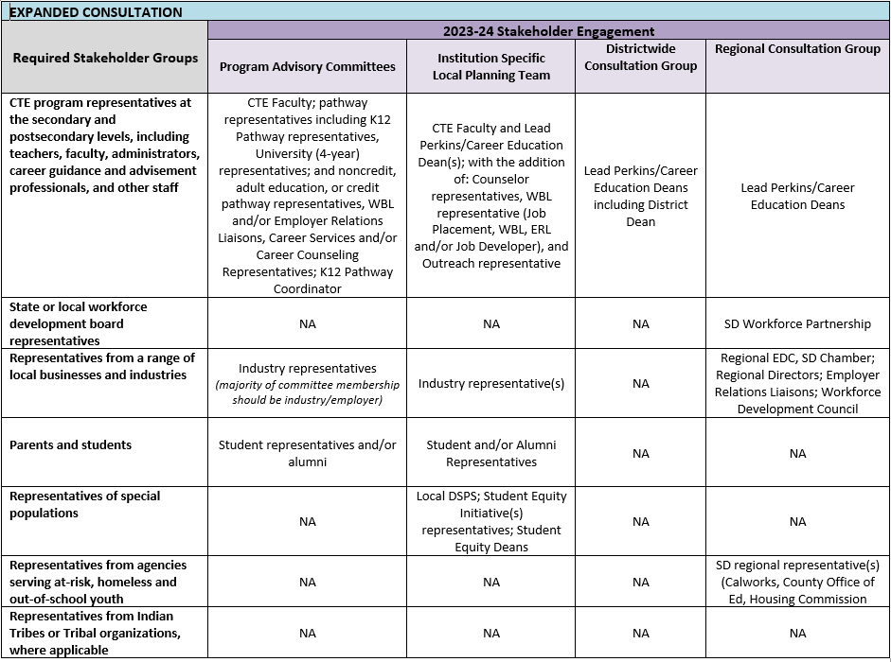

CLNA ELEMENT #1 - Student Performance

2020 CLNA priority strategies
The 2020 CLNA was submitted in spring of 2020 and impacted 2020-21 and 2021-22 Perkins projects
Add response here

Will your institution be continuing or revising these priorities?
Add response here

Data Reviewed
Opportunity to document/summarize/list the data reviewed internally and/or any related processes
Add response here

Observations made from data review(s) and constituent engagement activities
Opportunity to document/summarize observations made throughout process

What strengths and gaps were identified by your needs assessment regarding student performance?

What subpopulation of students could benefit from additional evidence-based services/supports?
Add response here

Priorities & Strategies

What priorities are you setting to address the gaps or challenges identified?
Required (one to five strategies)

What new or current partners (internal or external) will support priorities identified?

If applicable, what new and/or modified policies, evidence-based activities, or structures must be developed and implemented in order to improve student performance?
Add response here

Action Plan (s)
Required
The minimum components that must be addressed for each strategy are included below. No required format.

- Responsible parties - lead roles, departments, etc.
- Summary of specific data used to inform the strategy identified
- Timeline - Timeline for addressing the strategy (examples: two years, one year, Fall 2021, ongoing)
- Other institutional initiatives, regional initiatives, state or federal funds, etc. that may be leveraged to support the strategy (if applicable)
Add response here

CLNA ELEMENT #2 - Program Size, Scope, and Quality to meet the needs of all Students

2020 CLNA priority strategies
The 2020 CLNA was submitted in spring of 2020 and impacted 2020-21 and 2021-22 Perkins projects
Add response here

Will your institution be continuing or revising these priorities?
Add response here

Data Reviewed
Opportunity to document/summarize/list the data reviewed internally and/or any related processes
Add response here

Observations made from data review(s) and constituent engagement activities
Opportunity to document/summarize observations made throughout process

What strengths and gaps were identified by your needs assessment regarding student performance?

What subpopulation of students could benefit from additional evidence-based services/supports?
Add response here

Priorities & Strategies

What priorities are you setting to address the gaps or challenges identified?
Required (one to five strategies)

What new or current partners (internal or external) will support priorities identified?

If applicable, what new and/or modified policies, evidence-based activities, or structures must be developed and implemented in order to improve student performance?
Add response here

Action Plan (s)
Required
The minimum components that must be addressed for each strategy are included below. No required format.

- Responsible parties - lead roles, departments, etc.
- Summary of specific data used to inform the strategy identified
- Timeline - Timeline for addressing the strategy (examples: two years, one year, Fall 2021, ongoing)
- Other institutional initiatives, regional initiatives, state or federal funds, etc. that may be leveraged to support the strategy (if applicable)
Add response here

CLNA ELEMENT #3 - Progress towards Implementation of CTE Programs of Study/Career Pathways

2020 CLNA priority strategies
The 2020 CLNA was submitted in spring of 2020 and impacted 2020-21 and 2021-22 Perkins projects
Add response here

Will your institution be continuing or revising these priorities?
Add response here

Data Reviewed
Opportunity to document/summarize/list the data reviewed internally and/or any related processes
Add response here

Observations made from data review(s) and constituent engagement activities
Opportunity to document/summarize observations made throughout process

What strengths and gaps were identified by your needs assessment regarding student performance?

What subpopulation of students could benefit from additional evidence-based services/supports?
Add response here

Priorities & Strategies

What priorities are you setting to address the gaps or challenges identified?
Required (one to five strategies)

What new or current partners (internal or external) will support priorities identified?

If applicable, what new and/or modified policies, evidence-based activities, or structures must be developed and implemented in order to improve student performance?
Add response here

Action Plan (s)
Required
The minimum components that must be addressed for each strategy are included below. No required format.

- Responsible parties - lead roles, departments, etc.
- Summary of specific data used to inform the strategy identified
- Timeline - Timeline for addressing the strategy (examples: two years, one year, Fall 2021, ongoing)
- Other institutional initiatives, regional initiatives, state or federal funds, etc. that may be leveraged to support the strategy (if applicable)
Add response here

CLNA ELEMENT #4 - Improving recruitment, retention, and training of CTE professionals, including underrepresented groups

2020 CLNA priority strategies
The 2020 CLNA was submitted in spring of 2020 and impacted 2020-21 and 2021-22 Perkins projects
Add response here

Will your institution be continuing or revising these priorities?
Add response here

Data Reviewed
Opportunity to document/summarize/list the data reviewed internally and/or any related processes
Add response here

Observations made from data review(s) and constituent engagement activities
Opportunity to document/summarize observations made throughout process

What strengths and gaps were identified by your needs assessment regarding student performance?

What subpopulation of students could benefit from additional evidence-based services/supports?
Add response here

Priorities & Strategies

What priorities are you setting to address the gaps or challenges identified?
Required (one to five strategies)

What new or current partners (internal or external) will support priorities identified?

If applicable, what new and/or modified policies, evidence-based activities, or structures must be developed and implemented in order to improve student performance?
Add response here

Action Plan (s)
Required
The minimum components that must be addressed for each strategy are included below. No required format.

- Responsible parties - lead roles, departments, etc.
- Summary of specific data used to inform the strategy identified
- Timeline - Timeline for addressing the strategy (examples: two years, one year, Fall 2021, ongoing)
- Other institutional initiatives, regional initiatives, state or federal funds, etc. that may be leveraged to support the strategy (if applicable)
Add response here

CLNA ELEMENT #5 - Progress towards equal access to CTE programs for all students

2020 CLNA priority strategies
The 2020 CLNA was submitted in spring of 2020 and impacted 2020-21 and 2021-22 Perkins projects
Add response here

Will your institution be continuing or revising these priorities?
Add response here

Data Reviewed
Opportunity to document/summarize/list the data reviewed internally and/or any related processes
Add response here

Observations made from data review(s) and constituent engagement activities
Opportunity to document/summarize observations made throughout process

What strengths and gaps were identified by your needs assessment regarding student performance?

What subpopulation of students could benefit from additional evidence-based services/supports?
Add response here

Priorities & Strategies

What priorities are you setting to address the gaps or challenges identified?
Required (one to five strategies)

What new or current partners (internal or external) will support priorities identified?

If applicable, what new and/or modified policies, evidence-based activities, or structures must be developed and implemented in order to improve student performance?
Add response here

Action Plan (s)
Required
The minimum components that must be addressed for each strategy are included below. No required format.

- Responsible parties - lead roles, departments, etc.
- Summary of specific data used to inform the strategy identified
- Timeline - Timeline for addressing the strategy (examples: two years, one year, Fall 2021, ongoing)
- Other institutional initiatives, regional initiatives, state or federal funds, etc. that may be leveraged to support the strategy (if applicable)
Add response here

CLNA ELEMENT #6 - Alignment to Labor Market Information (LMI)

2020 CLNA priority strategies
The 2020 CLNA was submitted in spring of 2020 and impacted 2020-21 and 2021-22 Perkins projects
Add response here

Will your institution be continuing or revising these priorities?
Add response here

Data Reviewed
Opportunity to document/summarize/list the data reviewed internally and/or any related processes
Add response here

Observations made from data review(s) and constituent engagement activities
Opportunity to document/summarize observations made throughout process

What strengths and gaps were identified by your needs assessment regarding student performance?

What subpopulation of students could benefit from additional evidence-based services/supports?
Add response here

Priorities & Strategies

What priorities are you setting to address the gaps or challenges identified?
Required (one to five strategies)

What new or current partners (internal or external) will support priorities identified?

If applicable, what new and/or modified policies, evidence-based activities, or structures must be developed and implemented in order to improve student performance?
Add response here

Action Plan (s)
Required
The minimum components that must be addressed for each strategy are included below. No required format.

- Responsible parties - lead roles, departments, etc.
- Summary of specific data used to inform the strategy identified
- Timeline - Timeline for addressing the strategy (examples: two years, one year, Fall 2021, ongoing)
- Other institutional initiatives, regional initiatives, state or federal funds, etc. that may be leveraged to support the strategy (if applicable)
Add response here

Coordination Strategy
Required Narrative

Institutions will develop an ongoing strategy, process, or mechanism(s) to ensure the need assessment is used, with fidelity, to inform local planning and decision-making.

Provide responses to the following questions to the District:
Required. No word count max or min.

- What went well in your CLNA process?

- What could have been done differently to achieve better results?

- What individual or groups were invited but did not participate? Why did they not participate? What future steps will you take to engage them?

- What other initiatives can be leveraged and aligned across sectors to make this work successful?

- How will you build connections to and through those other initiatives?

- On what established schedule will you continue to meet and work together?

- How will you demonstrate collective commitment to on-going engagement in this work?

- In what ways did you consider districtwide and/or regional gaps, opportunities, or needs?

